Purpose of Gated Content Email Template
If you are looking to increase your email database, this email template will help with that! You will need a valuable piece of content (i.e. whitepaper, case study, eBook) to put behind a form so that you can capture the reader’s contact information.

Things to Consider
- Subject Line: Putting brackets around the word DOWNLOAD makes the action stand out
- Subject Line: Be direct about your download topic, it will provide true warm leads
- Body Content: Give specifics the download, the value proposition, and benefits
- Body Content: Always link the title to your content to the form fill. All links should point to the same action you want the reader to take
- Image: Try to always include an image of the download

EMAIL TEMPLATE

Sender: Your Email Address
Subject: [DOWNLOAD] Effective strategies to increase active student participation
Preview: Get your free eBook today and start improving student engagement tomorrow!

Hello [first name],

[PRESENT THE PROBLEM]
Teachers are always looking to improve active student participation, however they need new ways to motivate students to be vocal in the classroom and include quieter students in the conversation.

[INTRODUCE THE SOLUTION AND OFFER]
If you are currently encountering this issue, then you will want to check out ABC Education’s latest eBook Five Quick Strategies to Improve Student Engagement. Implementing these strategies will increase student engagement by 50% within the first week.
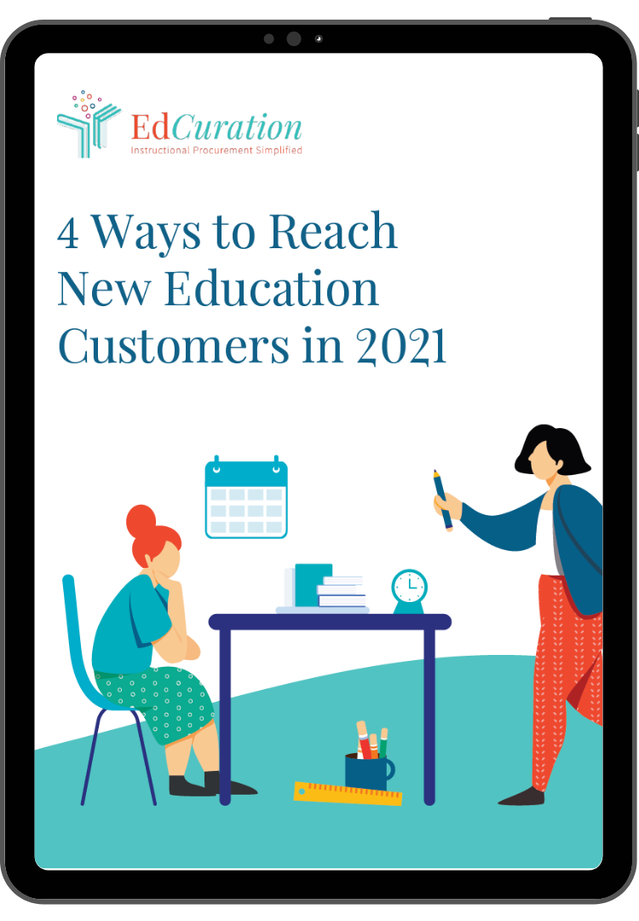
[VALUE PROPOSITION AND DOWNLOAD DETAILS]
In this eBook you will learn:
- Five strategies in receiving student feedback
- Peer assessment implementation
- Personalized learning
- And much more!

[CTA BUTTON] Get your eBook today

[CONVERSION OPPORTUNITY]
If you are looking for more information or want to have an in-depth conversation about professional learning opportunities with our team, feel free to contact us.

